**Experiment No 7**

**Objective: - Measurement of coefficient of discharge of Valve as function of valve lift.**

TEST RIG SPECIFICATIONS:

The test rig contains, a centrifugal blower with venturi meter, Ball valve & Cylinder head with valves.

The valve opening is controlled by a nut & screw mechanism.

**Measurement of:-**

* Valve geometry.
* Valve displacement.
* Flow rate through venturi & inlet pressure to the intake valve.
* Repeat the measurements for various flow rates.

**Prerequisites: -**

* Working principle of valves?
* What is a poppet valve?
* Name the geometrical parameters of a valve.

 **Experimental Procedure/what you should aim at: -**

* Start the blower and adjust the blower ball valve to set the flow rate.
* Fully open the engine intake valve.
* Measure the pressure difference across venturi.
* Also measure the inlet pressure to the intake.
* Repeat above steps for various valve positions.
* Repeat above steps for various blower flow rates.
* Obtain a relation/curve between valve lift & coefficient of discharge.

**What next (Things you can ponder over):-**

* Is there a smooth relation between Cd & Valve lift ?
* If not explain the nature of the relation?
* Identify the reasons for the discontinuous relation?
* Suggest a method to improve the design of valves?

**Submission of Report:**

* A single report per group.
* All are equally responsible for the preparation of the report.
* Should answer the questions on your report.
* Each Report will be evaluated for 10 points.

**References:-(Books to consult)**

1. IC Engines by Heywood.

**Theory:**

**Geometrical Description of a valve:**

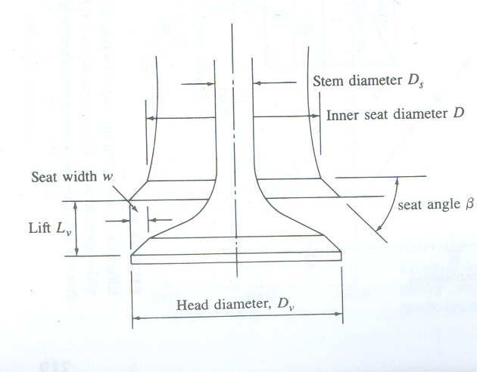

**Stages of Valve Lift:**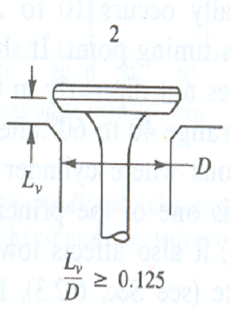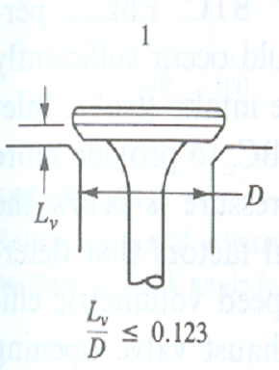

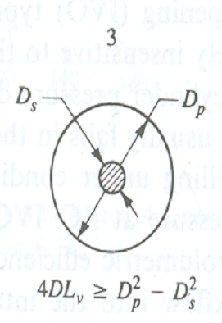

**Instantaneous flow area:**

***Stage 1: Valve lift Lv***

***Stage 2: Valve lift Lv***

***Stage 3: Valve lift Lv***



Frictional Compressible Flow Through Inlet Valves



Where:

CD = Coefficient of discharge of the valve at a given lift.

pinlet : Inlet manifold pressure.

Tinlet: Inlet manifold temperature.

pcyl: Cylinder pressure.